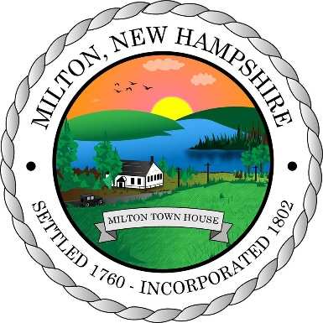
Town of Milton
Board of Selectmen Meeting Agenda
June 22, 2026
55 Industrial Way, Milton, NH
Public Hearing Notice

The Milton Board of Selectmen will hold a public hearing on June 22, 2026 beginning at 6:00 pm at the Milton Town Hall, 55 Industrial Way, Milton, NH 03851. The purpose of the hearing is to receive public input on the proposed PILOT (Payment In Lieu of Taxes) Agreement between the Town of Milton and Kearsarge Solar LLC for the proposed Solar Facility located at 120 McKeagney Rd. The proposed PILOT Agreement can be viewed at the Milton Town Hall, 55 Industrial Way, Milton, NH 03851.

