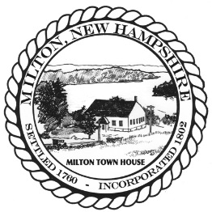
Town of Milton Zoning Board of Adjustment
55 Industrial Way
Milton NH, 03851 (p)603-652-4501
(f)603-652-4120

Agenda

Zoning Board of Adjustment
Thursday, May 28, 2026
6:00 PM
- Call to Order- Roll Call to determine Quorum

- Public Comment on issues not before the Board
- Review/Approval of Minutes of March 26, 2026, meeting

- Continued Public Hearing for an application for variances submitted by Walter Cheney, applicant and WWC 10 LLC & Real Estate Advisors, owners at Mason Road, Map 26, Lot 18 & Map 31, Lot 1 (the “Property”). The Application seeks relief from MZO Article III, Section 3.5-Table of Principal Uses on p.15 and MZO Article VI-Open Space Development (OSD), 7.a. to permit the application to the Planning Board for an Open Space Development that proposes 98- one & two bedroom condominiums in eight multifamily buildings where multifamily dwellings/structures are not allowed. The property is in the low-density residential zoning district.

- Public Hearing for an application for a Variance submitted by Jeffrey Brunelle, applicant and owner at 818 White Mtn Hwy, Map 32, Lot 143 (the “Property”). The Application seeks relief from Milton Zoning Ordinance Article XX, Sign Ordinance, 6. d) to allow an existing electronic sign board to remain where internally illuminated, flashing and scrolling signs are not permitted. The property is in the commercial-residential zoning district.
- Public Hearing for an application for a REVISED variance submitted by Craig Swanson, applicant, owners Craig & Heather Swanson at 136 Branch Hill Road, Map 11, Lot 5 (the “Property”). The Application seeks relief from Milton Zoning Ordinance Article 3.5, Table of Dimensional Requirements on p. 17, to construct a garage that will have a minimum of 17-ft. where the original variance granted was for 31-ft. of front setback where 40-ft. is required and have a side setback 24-ft. where 25-ft. is required. The property is in the low-density residential zoning district.

- Other Business

- Adjournment

