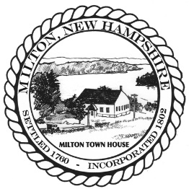
Town of Milton Planning Board
55 Industrial Way PO Box 310
Milton NH, 03851 (p)603-652-4501

Notice

Planning Board
Meeting Scheduled for
Tuesday, July 7th, 2026
Has Been Cancelled

