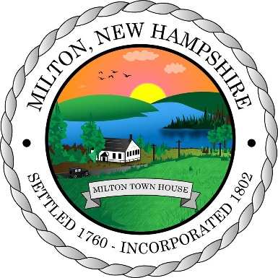
Town of Milton
Board of Selectmen Meeting Agenda
June 22, 2026
Milton Town Hall
Non - Public Session 5:30 PM:
- RSA 91-A:3 II (a) Recreation
- RSA 91-A:3 II (a) Police
- RSA 91-A:3 II (a) Fire Department
- RSA 91-A:3 II (a) Department of Public Works
- RSA 91-A:3 II (a) Town Administration

Public Session 6:00 PM

Pledge of Allegiance

Chairman to announce guidance for public comment and public comment pertaining to topics previously discussed.

“At this time, we will open the meeting to public comment. We respectfully request that items already on the agenda not be addressed and that your comments be limited to 3 minutes so that everyone can have the opportunity to address the Board. Later in the agenda there will be a second opportunity to address items raised during the meeting.”

Public Comment

Announcements and Community Calendar

- Please help to protect our lakes and drinking water, clean up your yard and pet waste.
- Milton Town Beach Summer Hours begin June 22nd. Gate house is not occupied daily until after that date. If you need assistance, please contact the Recreation Department at Town Hall.
- The Town has a couple of boards and committees looking for volunteers. The Planning Board is currently looking for 2 Alternate members, Capital Improvement Committee is looking for 1 Alternate At-Large member, and the Milton Economic Development Committee is looking for 5 At-Large members and 2 At-large Alternate Members. Please contact the Town Administrator if you are interested in volunteering for one of these Boards or Committees.

NEW BUSINESS:
- Public Hearing for Proposed PILOT Agreement between Kearsarge Energy and Town of Milton
- Motion to formally accept sewer abatements
- Primex Return of Surplus notifications
- Sewer Department update for Board of Selectmen
- Review Energy Audit for Fire Station
- Follow-up on conversation with Milton Conservation Commission about possible Christmas Tree Farm-Selectmen Golab
- Proposed Appointed Fire Chief Job Description
- Dog Warrant 2026

EVENT PERMITS:
- None
OLD BUSINESS:
- Winding Bridge
- Long Term Goal-update Town Website to improve functionality: update should be live end of June 2026
- Work on Insurance Buy-out cost/plan (12/16/2024)
- Beach Gates December Opening for Winter usage of property to follow snowmobile club plans.
- SolSmart Feasibility Report –Future review and plan creation.
- Energy Audit for Town Hall and Fire Station-onsite reviews completed, report pending.
- Dawson Street Traffic Study-Update May 4, 2026

Communications Received:
- None

Other Business That May Come Before the Board

Approval of Minutes

Non-public Minutes
none
Public Minutes:
- June 1, 2026

Public Comments Pertaining to Topics Previously Discussed

Expenditure Report

Town Administrator
- The next regular meeting of the Board of Selectmen will be July 6, 2026
- A more detailed report may be read at the meeting.

Selectmen Comments

Adjournment of Public Meeting

