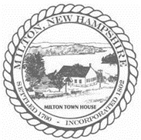
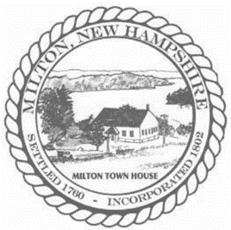
Town of Milton
Board of Selectmen Meeting
With Budget Committee
November 17, 2022
Milton Town Hall
AGENDA

Public Session 6:00PM

Pledge of Allegiance

The purpose of the meeting is to review and discuss the FY2023 Budget with the Budget Committee.

